**Workshop Project**



Session: 2021 – 2025

**Submitted by:**

Abdul Mateen       2021-CS-190

Muhammad Ibrahim 2021-CS-190

**Supervised by:**

Hafiz Furqan Sabir

Department of Computer Science

**University of Engineering and Technology**

**Lahore Pakistan**

**Raw Material:**

To make the adjustable wranch we need a 32 number ring spanner. And a net bolt.

* Spanner

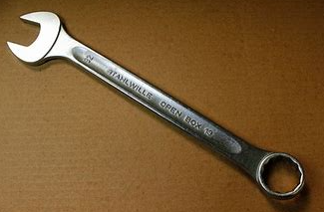

* Net bolt

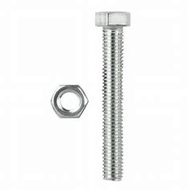

* Machinery

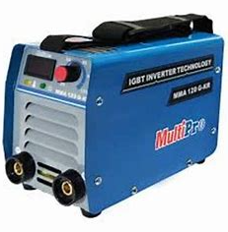

**Process:**

First we took a spanner and remove the top part of its head. Then we joined the bolt to the head using welding Plant .And the final product is ready.

**Final Product:**

